**EGE UNIVERSITY**

**ENGINEERING FACULTY**

**COMPUTER ENGINEERING DEPARTMENT**



**2019-2020**

**IMAGE PROCESSING**

**PROJECT 1 REPORT**

**DENİZ YÜREKDELER**

**05180000017**

TABLE OF CONTENTS

Introduction 5

Browsing Images and Videos 6

Image Enhancement and Filters 8

Gray Filter 8

Blur Filter 9

Sharp Filter 9

Mean Filter 9

Motion Blur Filter 10

Lighten Filter 10

Darken Filter 11

Invert Color Filter 11

Gaussian Blur Filter 12

Bilateral Blur Filter 12

Finding Edges Filter 13

Intensity Processing 13

Intensity Level Adjustment 13

Spatial Image Processing 14

Rescale 14

Resize 14

Downscale 15

Rotate 15

Swirl 16

Hıstogram Plotting and Equalization 16

Histogram 16

Equalization 17

Morphologic Processing 18

Erosion 18

Dilation 18

Opening 18

Closing 19

Gradient Filter 20

Top Hat 20

Black Hat 20

Video Processing 21

Özdeğerlendirme Tablosu 22

Explanations 23

1. Application reads images/videos with Browse buttons and loads them to MatPlotLib canvas and can save images with MatPlotLib ToolBar’s save button. 23

References 24

TABLE OF FIGURES

Table 1 Browsing and Loading an Image to Image World Application 6

Table 2 Selecting a Filter to Apply and Give It Optional Value 8

Table 3 Original Image and Gray Filtered Result 8

Table 4 Original Image and Blur Filter Result 9

Table 5 Original Image and Sharpen Filter Result 9

Table 6 Original Image and Mean Filter Result 10

Table 7 Original Image and Motion Blur Filter Result 10

Table 8 Original Image and Lighten Filter Result 11

Table 9 Original Image and Darken Filter Result 11

Table 10 Original Image and Invert Filter Result 12

Table 11 Original Image and Gaussian Blur Filter Result 12

Table 12 Original Image and Bilateral Filter Result 13

Table 13 Original İmage and Find Edges Filter Result 13

Table 14 Original Image and Intensity Filter Result 14

Table 15 Original Image and Rescaling Result 14

Table 16 Original Image and Resizing Result 15

Table 17 Original Image and Downscaling Result 15

Table 18 Original Image and Rotating Result 16

Table 19 Original Image and Swirling Result 16

Table 20 Plotting Histogram of Image 17

Table 21 Plotting Histogram Equalization of Image 17

Table 22 Original Image and Erosion Filter Result 18

Table 23 Original Image and Dilation Filter Result 18

Table 24 Original Image and Opening Filter Result 19

Table 25 Original Image and Closing Filter Result 19

Table 26 Original Image and Gradient Filter Result 20

Table 27 Original Image and Top Hat Filter Result 20

Table 28 Original Image and Black Hat Filtering 21

Table 29 Laplace and Canny Filtering on Video 21

# Introduction

This project aims to improve practical and theorical knowledge of image processing techniques by developing and image processing application with a grapical user interface to aplly numerous filters on desired pictures and videos. The application developed for this project is called “Densy’s Image World”.

Densy’s Image World application offers users to select among a total of twenty seven distinct image filterings and thirteen of them can be used with either default or user-entered value(s). For video processing, there are two distinct filterings which are canny and laplacian edge detections.

# Browsing Images and Videos

As shown in the Table 1 , after starting Densy’s Image World application, users can choose either browsing an image or an video to apply filters on these.

Browsing an image or a video pops up a file input window where user can navigate between directories and select one appoporiate formatted file to load it in the application’s canvas.

For image loading, JPEG and PNG files and for video loading, MP4, WMV and AVI files are allowed.

Users can switch between these types on the “Select A File” window.

Since no any filterings work when an file is not loaded into the canvas. This step is obligated to users who would like to use this application.

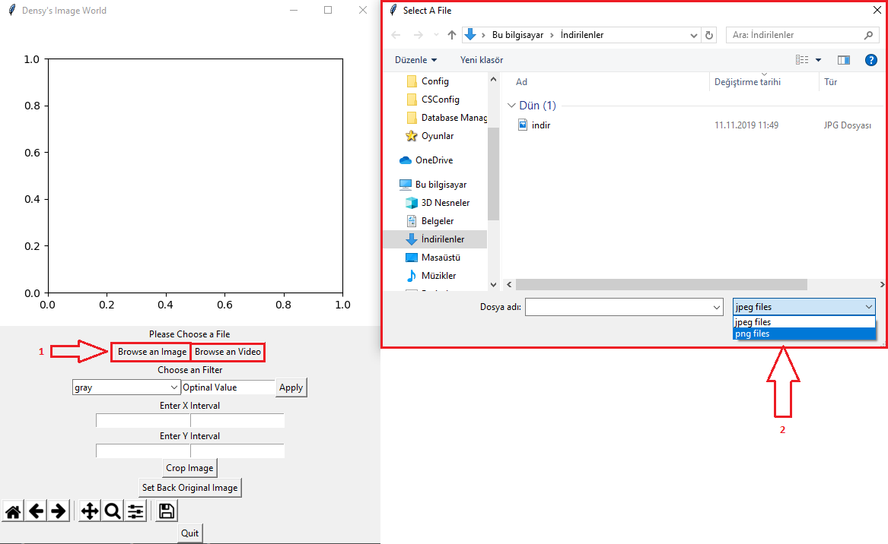

Table 1 Browsing and Loading an Image to Image World Application

On the application’s window theare are several elements users can interact with.

There is a combobox whish contains most of the filters. Users can choose any filter from this combobox to apply on the image. The input element right next to this combobox is for applying custom values on some filters. This area can be left blank to use filter’s default value.

When an integer is given to the input element eligable filters will apply with the custom value.

After choosing one filter from the combobox and optionally filling the input users can click on “Apply” button that is positioned in the same row with the combobox and the input element.

“Apply” button applies the selected filter to the image and shows the filtered new version on the same canvas where the original image is placed.

Users can apply filters one after another without the need to revert the image to the original but all the filters will be applied onto the original image.

There is also a button which is called “Set Back Original Image”for users who would like to clear any filter applied.

Below the filters combobox there are four inputs and one “Crop Image” button placed in a group. By filling these areas and clicking “Crop Image” button users can crop the image within the desired ranges. If any of these coordinate inputs are left blank, that coordinate will be set to default value.

At the very end of these elements there is a toolbar which is provided by MatPlotLib package. This toolbar allows users to zoom in and out to selected area of the image. Switch to previous and next views of the image. Move the image inside the canvas, set back to default and save the image inside the canvas to desired directory.

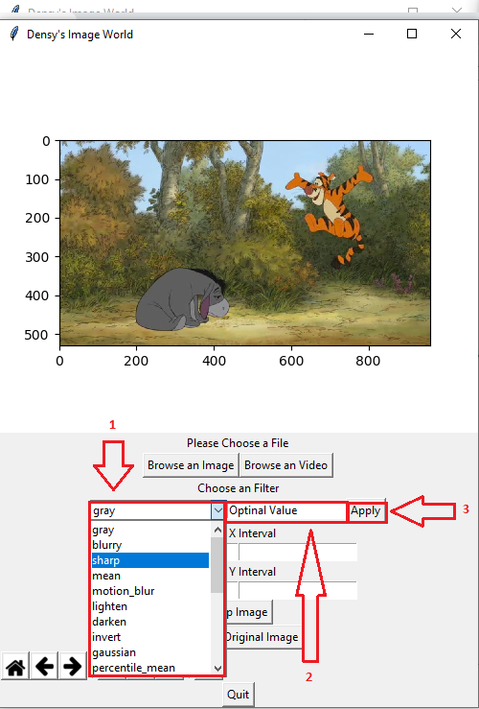

Table 2 Selecting a Filter to Apply and Give It Optional Value

# Image Enhancement and Filters

For image enhancement and filtering users can choose any of “gray, blurry, sharp, mean, motion_blur, lighten, darken, inverti gaussian, percentile_mean, bilateral_mean, find_edges” filters from the combobox.

## Gray Filter

Gray filters takes an image and converts to to graysclae by using “rgb2gray()” method.

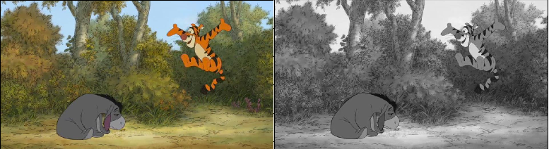

Table 3 Original Image and Gray Filtered Result

## Blur Filter

Blur filter takes an image and it applies homogenous blur to the image with the default of (11, 11, 1) sized array. This filter’s value can be determined by the user with the “Optional Value” input element.

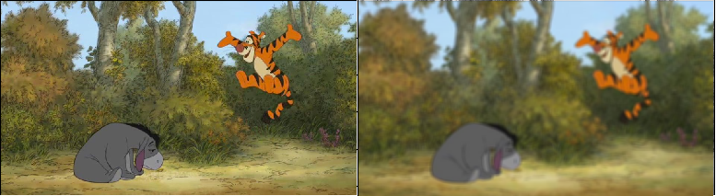

Table 4 Original Image and Blur Filter Result

## Sharp Filter

This filter is sharpening the given image with the “unsharp_mask()” method with the default radius of 5.

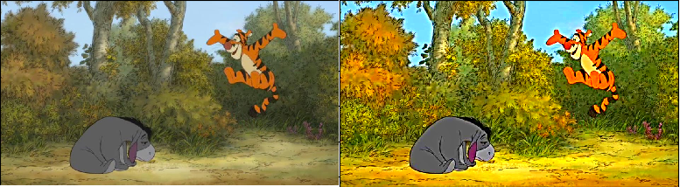

Table 5 Original Image and Sharpen Filter Result

## Mean Filter

This filter is applying mean filtering (softening edges/blurring) technique to the image with default value 9. Value of this filter can be given by the users.

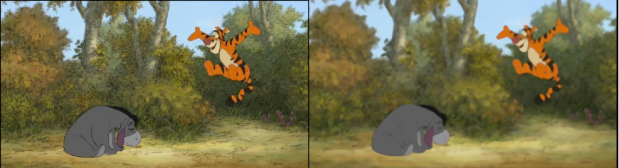

Table 6 Original Image and Mean Filter Result

## Motion Blur Filter

This filter is appling a form of blur to the image which makes it look like it is moving left and right. For creating this filter a kernel is created with default size 50 and applied to the image. This filter’s value can be given by the users.

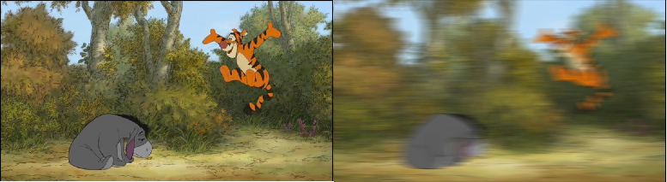

Table 7 Original Image and Motion Blur Filter Result

## Lighten Filter

This filter lightens the color scale of the given image by adding default 50 sized array from the image. Users can give this filter custom values.

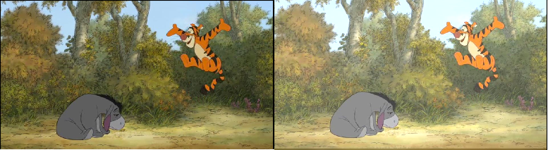

Table 8 Original Image and Lighten Filter Result

## Darken Filter

This filter darkens the color scale of the given image by subtracting default 50 sized array from the image. Users can give this filter custom values.

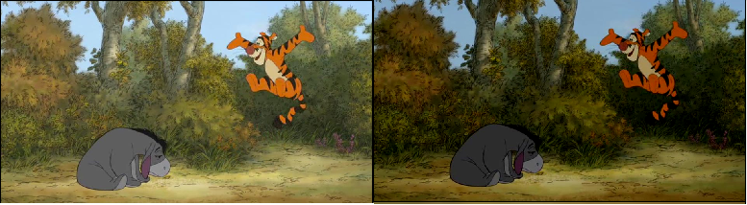

Table 9 Original Image and Darken Filter Result

## Invert Color Filter

This filter inverts the colors of the given image.

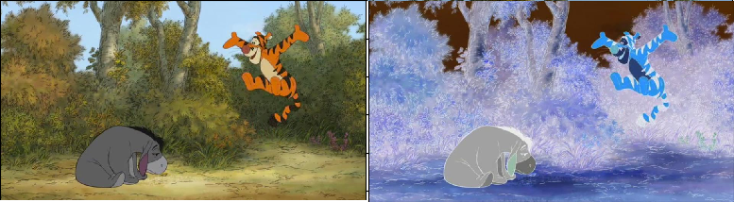

Table 10 Original Image and Invert Filter Result

## Gaussian Blur Filter

This filter applies gaussian blur filter on the image with default 25 size. Users can give custom values to this filter.

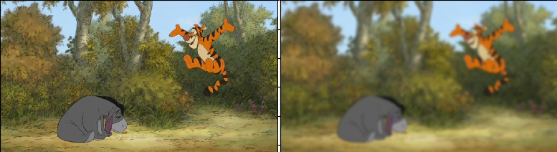Table 11 Original Image and Gaussian Blur Filter Result

## Bilateral Blur Filter

This filter applies bilateral blur filter on the image with default 30 size. Users can give custom values to this filter.

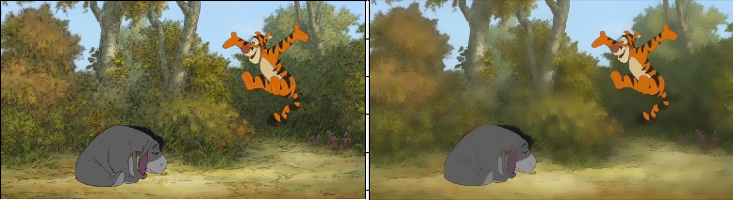

Table 12 Original Image and Bilateral Filter Result

## Finding Edges Filter

This filter converts the given image to gray and then uses “sobel()” method to find edges of the given image.

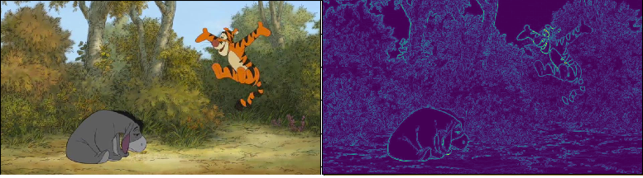

Table 13 Original İmage and Find Edges Filter Result

# Intensity Processing

## Intensity Level Adjustment

In this filter, user selects intensity option from the combobox and gamma correction is applied to the image with default gamma 1.5. Users can give smallar or bigger values.

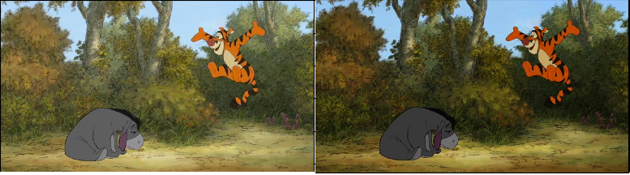

Table 14 Original Image and Intensity Filter Result

# Spatial Image Processing

## Rescale

After converting the image given to gray scale users can rescale the given image by using the default or custom given value.

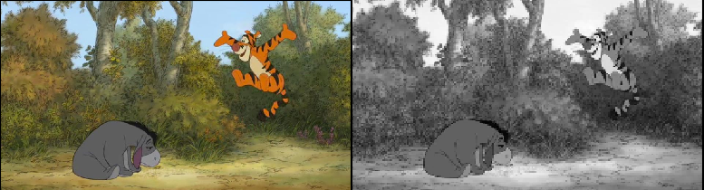

Table 15 Original Image and Rescaling Result

## Resize

After converting the image given to gray scale users can resize the given image by using the default or custom given value. Resizing simply divides the image array with the given/default size.

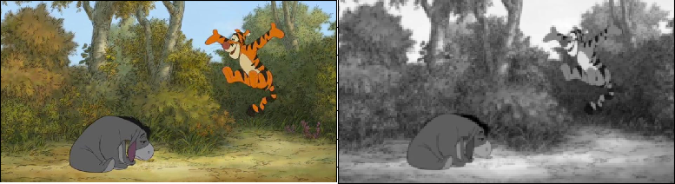

Table 16 Original Image and Resizing Result

## Downscale

After converting the image given to gray scale users can downscale the given image by using the default or custom given value.

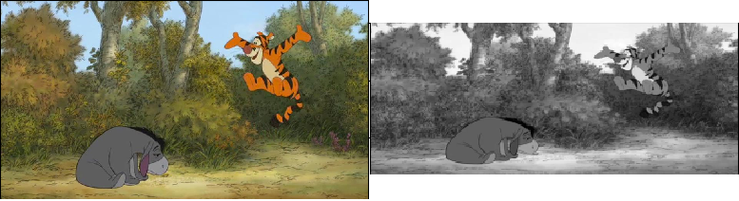

Table 17 Original Image and Downscaling Result

# Rotate

Users can rotate the image by giving custome degrees. If the optional value is left blank application will rotate the image by 180 degrees.

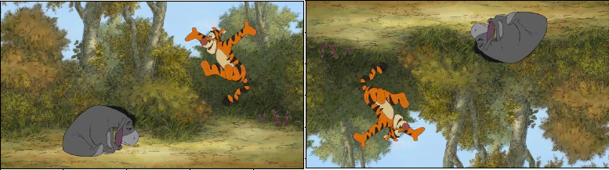

Table 18 Original Image and Rotating Result

## Swirl

Users can swirl the image by default size 250 or give a custom value. As the size gets bigger also does the swirl effect.

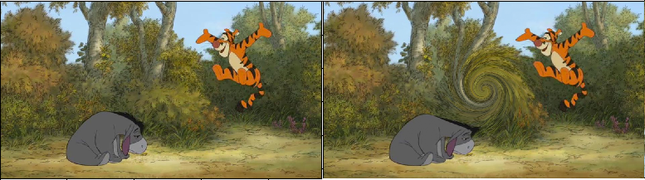

Table 19 Original Image and Swirling Result

# Hıstogram Plotting and Equalization

## Histogram

After loading an image to the canvas users can select “histogram” option from the combobox to plot image’s histogram. For this firstly image is converted to gray scale and after plotting process finishes a new window opens which is showing the histogram of the image.

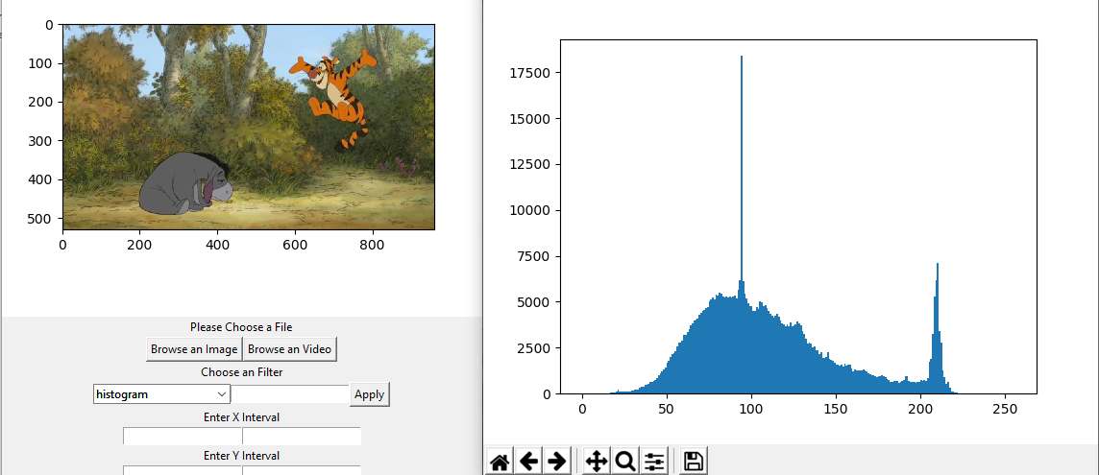

Table 20 Plotting Histogram of Image

## Equalization

Users can view the equalizad histogram of the image by selecting “equalization” from the combobox. Equalization is not needed to be preceded by histogram plotting.

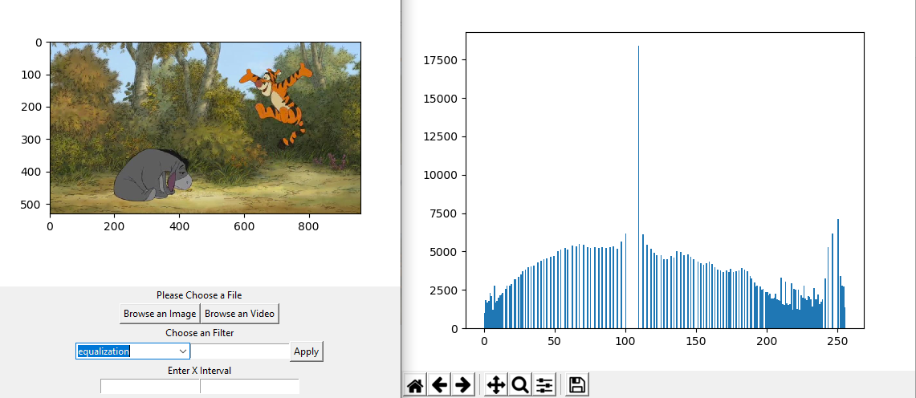

Table 21 Plotting Histogram Equalization of Image

# Morphologic Processing

## Erosion

Erosion is applied to the image with the 5 sized kernel array.

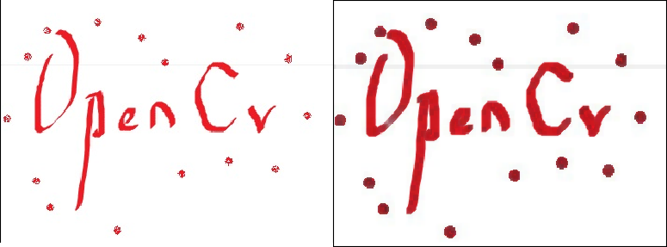

Table 22 Original Image and Erosion Filter Result

## Dilation

Dilation is applied to the image with the 5 sized kernel array.

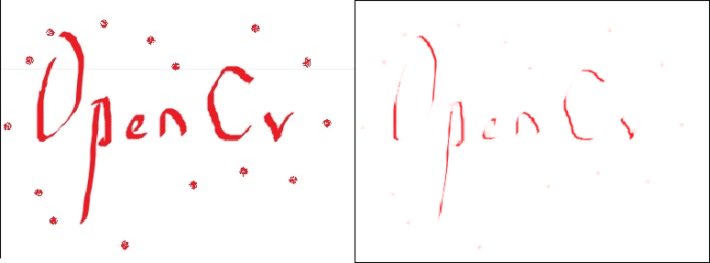

Table 23 Original Image and Dilation Filter Result

## Opening

Opening is applied to the image with the 5 sized kernel array.

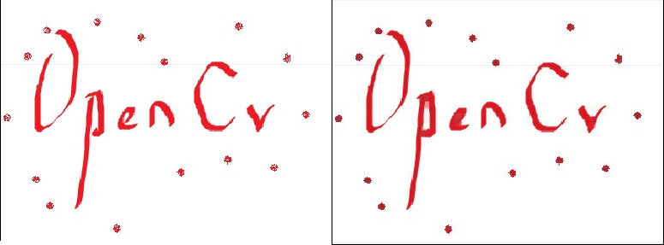

Table 24 Original Image and Opening Filter Result

## Closing

Closing is applied to the image with the 5 sized kernel array.

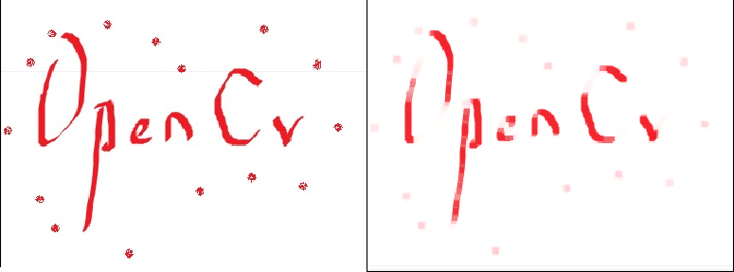

Table 25 Original Image and Closing Filter Result

## Gradient Filter

Gradient filter is applied to the image with the 5 sized kernel array.

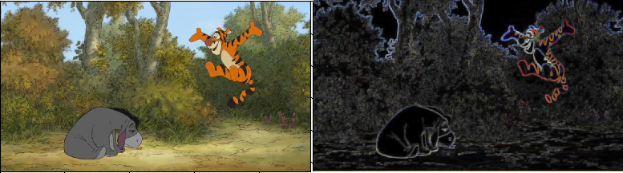

Table 26 Original Image and Gradient Filter Result

## Top Hat

Top hat is applied to the image with the 5 sized kernel array.

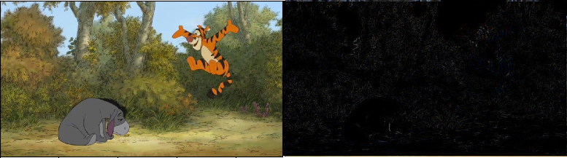

Table 27 Original Image and Top Hat Filter Result

## Black Hat

Black hat is applied to the image with the 5 sized kernel array.

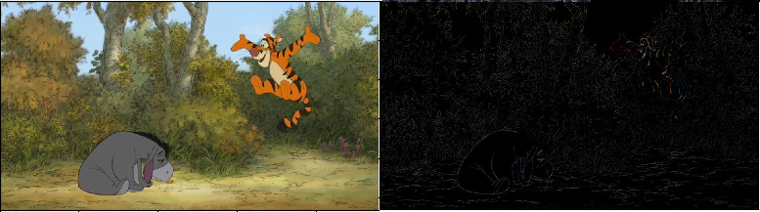

Table 28 Original Image and Black Hat Filtering

# Video Processing

After users browse a video file it automatically starts the video in two different filters. Users can pause the video by pressing “Q” button and then can close windows of the video.

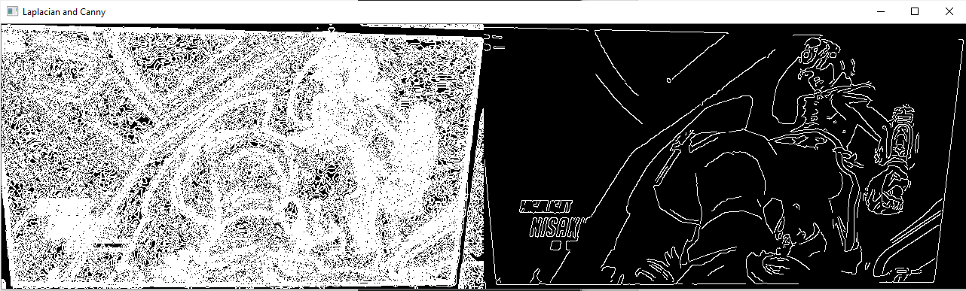

Table 29 Laplace and Canny Filtering on Video

# Özdeğerlendirme Tablosu

|  |  |  |  |  |  |  |
| --- | --- | --- | --- | --- | --- | --- |
|  | İstenen Özellik | Puan | | Var | Açıklama | Tahmini Puan |
| **1** | Görüntü Yükleme ve Kaydetme (Load/Read, Save) | 10 |  | | **Explanations 1** | **10** |
| **2** | Arayüz / Form Ortamı Hazırlama | 10 |  | | **Explanations 2** | **10** |
| **3** | Görüntü İyileştirme İşlemleri, Filtreler (10 farklı filtre içermeli)  <https://scikit-image.org/docs/stable/api/skimage.filters.html> | 10 |  | | **Explanations 3** | **10** |
| **4** | Histogram Görüntüleme ve Eşikleme  <https://scikit-image.org/docs/stable/api/skimage.exposure.html#skimage.exposure.histogram> | 10 |  | | **Explanations 4** | **10** |
| **5** | Uzaysal Dönüşüm İşlemleri (Resizing, Rotation, Cropping, Swirl … gibi 5 farklı dönüşüm işlemi içermeli)  <https://scikit-image.org/docs/stable/api/skimage.transform.html> | 10 |  | | **Explanations 5** | **10** |
| **6** | Yoğunluk Dönüşümü İşlemleri (Değerleri kullanıcı verebilmeli)  <https://scikit-image.org/docs/dev/api/skimage.exposure.html#skimage.exposure.rescale_intensity> | 10 |  | | **Explanations 6** | **10** |
| **7** | Morfolojik İşlemler (10 farklı morfolojik işlem içermeli)  <https://scikit-image.org/docs/stable/api/skimage.morphology.html> | 10 |  | | **Explanations 7** | **7** |
| **8** | Video İşleme (Videoda kenar belirleme gibi bir örnek yeterli)  Herhangi bir ortamda yapabilirsiniz. | 10 |  | | **Explanations 8** | **10** |
| **9** | **Rapor Biçimi, Düzeni ve Özdeğerlendirme Raporu**  **Yukarıdaki 8 madde raporda ayrı başlıklar halinde verilerek açıklanmalı.**  **Raporda** her bir maddedeki her bir örnek için, işlemden önceki ve sonraki ekran görüntüleri olmalı.  **Bu özdeğerlendirme tablosunu doldurarak raporunuzun sonuna ekleyiniz.** | 20 |  | | **Explanations 9** | **18** |
| **Toplam** | | | | | | **95** |

## Explanations

### Application reads images/videos with Browse buttons and loads them to MatPlotLib canvas and can save images with MatPlotLib ToolBar’s save button.

1. Application welcomes users with a graphical user interface which is simple but effective enough to complete all desired actions. It could use some more improvements such as coloring, placement, icons.
2. There are total of 11 image enchancement filters in the application. Users can give custom value to most of these filters.
3. Histogram and the equalization of the given image is showned in the extra windows. Application automatically closes these extra windows when another filter is selected and applied.
4. There are total of 11 spatial filters in the application. Users can give custom value to most of these filters. For cropping the image users are allowed to select image intervals.
5. Intensity level can take any float value from the user.
6. There are only 7 morphologic filters in the application users can give custom values to most of these filters. More research could have done to find 3 more filters.
7. There are 2 different edge finding filter for viode processing. Both of the filters are played synchronized in the same windowed next to each other.
8. Report’s format is easy to read but explanations could be more specific.

# References

* Getting Started with Videos :

<https://opencv-python-tutroals.readthedocs.io/en/latest/py_tutorials/py_gui/py_video_display/py_video_display.html>

* Getting Started with Images :

<https://opencv-python-tutroals.readthedocs.io/en/latest/py_tutorials/py_imgproc/py_table_of_contents_imgproc/py_table_of_contents_imgproc.html>

* Python GUI Tkinker :

<https://www.geeksforgeeks.org/python-gui-tkinter/>

* Embeding MatPlotLib to Tkinter :

<https://matplotlib.org/3.1.0/gallery/user_interfaces/embedding_in_tk_sgskip.html>